**Student:**

1. Registration- Sign Up:

* Name, Mobile No, Class, Degree, Email, Course

1. Login

* Login Id, Password
* Change Password

1. Profile- Right Most Section

* First Name
* Last Name
* Photo
* Email
* Course
* Semester
* Date of Birth
* Phone No

**Menu Option:**

* Dashboard
* Upcoming Class:
* Course Name:
* Techer Name:
* Link to Join
* Quizzes Due
* Pending Assignment
* Announcement

Result from Recent Assignment or Quiz

* Program -Name (Side Bar Classes his enrolled In)

English ->

* **Live Classes**

Link to Join the class

Teacher Name

* Recorded Lectures->{Calendar}Which lecture want to navigate}
* Quizzes
* Course Material
* Discussion Forums
* Assignments

Maths -> **Live Classes** Recorded Lectures->{Calendar}Which lecture want to navigate

…

3.Calendar

* Time Table-> Head of Department
* Program in Schools and Uploaded by Admin/HR/Head of Department

**4.Results**

1)Assignment

2)Quizzes

3)Subject Wise Performance:

a) Red: Low

b) Orange: Between 60-70 & Attendance

c) Green: 70-80

d)Yellow: Above 80

5. Request Document: {This need to be done by Registrar}

* Migration Certificate {Arabic or English Language}
* LOR {Arabic or English Language}
* Mention Certificate Name {Arabic or English Language}

**When Student Enter into the meeting attendance get marked.**

**Teacher:**

Login Id, Password

Profile- Right Most Section

* First Name
* Last Name
* Photo
* Email
* Date of Birth
* Phone No
* Department Name

1.Dashboard

1. Upcoming Classes: Whiteboarding, Zoom Call

* Class Name
* Time:
* Date:
* Link to start the meeting

2.Announcement

2.Classes ->Tagged by Head of Department

1. Program -Name

* English
* View the Students: ID , Name, Color-coded, Marks, Attendance %age, **Student ID, Pending Quizzes or Assignment**

**Email student for Reminder**

* Start the Meeting
* Upload the Class Material
* Upload the Video Recording
* Maths
* View the Students: Name, Email
* Upload the Class Material
* Upload the Video Recording

2.Class 2

,,,

* Create Quizzes

1.Class 1

* English
* Quiz 1
* Maths

2.Class 2

* English
* Quiz 1
* Maths
* Assignment
* Create Assignment and Assignment Marks

1. Program -Name

* English
* View Assignment:

Student Name, Student ID & Assignment Submitted by Student and Evaluate (Grade out of marks decided)

* Maths

2.Class

* Calendar
* Class Scheduled
* Events
* Leave Application when the date is clicked-> Go to HR/HOD
* Forum
* View Student Chat and Respond to it.
* Request Document: {Need to be Done by HR}
* Salary Slip
* Letter to Bank or Government Entity

**Head of Department- Program**

Login Id, Password

Profile- Right Most Section

* First Name
* Last Name
* Photo
* Email
* Date of Birth
* Phone No
* Department Name

**1.Dashboard**

**2.Classes**

1.Program -Name

* Create Classes (Video Meets) and Add Subjects and Tag Teacher
* Schedule Time Table in Calendar

2.Class 2

**3.Manage Teachers**

* View All teachers tagged to this Department
* Can Views Leaves of teachers
* When click on teachers can view, edit and cancel the schedule of teachers

**4.Announcements**

* Shout Announcement
* View Announcement

**5. Calendar**

* Events Scheduled
* Meeting with HR, Administrator, Teachers,
* Submit Leaves to HR with Leave Form

6. Request Document: {Need to be Done by HR}

* Salary Slip
* Letter to Bank or Government Entity

**Email ID FOR SIGN UP SHOULD BE UNIQUE AND THAT SHOULD BE THE PRIMARY KEY TILL PAYMENT IS CONFIRMED by Accountant , This will be used by Registrar and Administrator, HR**

**Registrar**

Login Id, Password

Profile- Right Most Section

* First Name
* Last Name
* Photo
* Email
* Date of Birth
* Phone No

1. Dashboard

* Number of New Submission
* Number of Pending Submission

1. Submission

* Pending
* View Complete Student Details filled by Administrator with the administrator’s name
* Option to Approve
* Approved
  + 1. View Student Details with Administrator Name

1. Calendar

Apply Leave

* Request Document: {Need to be Done by HR}
* Salary Slip
* Letter to Bank or Government Entity

1. Request Letter by Student

* View Student Details and Upload the document
* Submitted

1. Request Document: {Need to be Done by HR}

* Salary Slip
* Letter to Bank or Government Entity

**Administrator**

Login Id, Password

Profile- Right Most Section

* First Name
* Last Name
* Photo
* Email
* Date of Birth
* Phone No

1. Dashboard

* Number of New Student Sign Up
* Number of Pending Approval from Registrar

1. Student

* View All Student Signed Up
* Connect with them and complete the Student Form

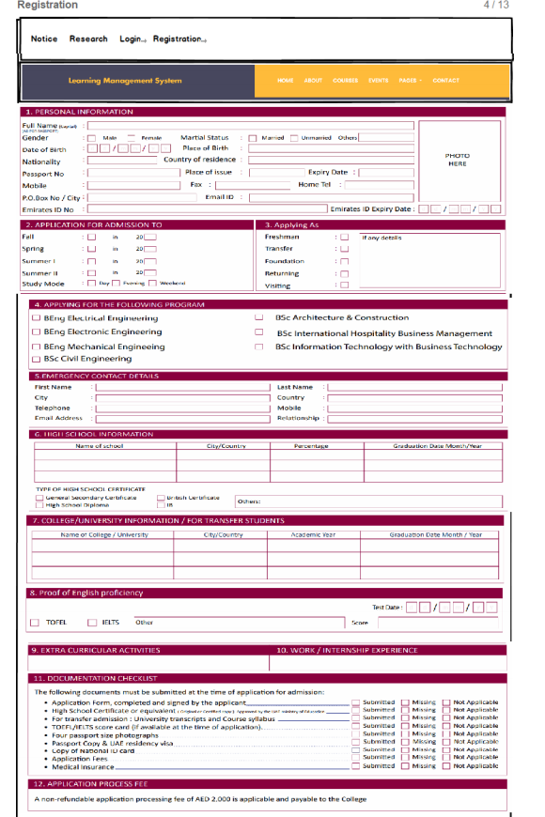

3.Approval Status

* Pending

Student Name & Student Email ID

* Approved
* Student Name & Registrar Name
  + Send the Payment Link (Its Fixed 2000AED)

4.Payment Approved (By Accountant)

* Pending

Student Name & Student Email ID

* Approved
* Student Name & Accountant Name & Mode of Payment :Cash, Credit Card, Debit Card

**Generate ID & Password for Student and send mail to them for the same**

5.Calendar

Apply Leave to HR

6. Request Document: {Need to be Done by HR}

* Salary Slip
* Letter to Bank or Government Entity

**Accountant**

Login Id, Password

Profile- Right Most Section

* First Name
* Last Name
* Photo
* Email
* Date of Birth
* Phone No

1. Dashboard
   1. No of Pending payments
2. Payment

* Online Mode: Display Student Email Id, Name, Phone No & Payment Status
* Cash Payment Done Then Add Receipt No

1. Calendar

* Apply Leave to HR

1. Expenses

* Payslip generated by HR ->Approve Salary
* Upload the Purchase Invoice
* Add any Expenditure with Money

1. Request Document: {Need to be Done by HR}

* Salary Slip
* Letter to Bank or Government Entity

**HR (Super Admin)**

Login ID, Password

Profile- Right Most Section

* First Name
* Last Name
* Photo
* Email
* Date of Birth
* Phone No

1. Dashboard
   1. No of Teachers
   2. No of HODS
   3. No of Administrator
   4. No of Registrant
   5. No of Accountant
   6. Pending evaluation:

It’s about to become 3 months

* 1. No of Pending leave Request

1. Administrator

* All Administrator
  + Edit Details
  + Evaluation: {HR SHOULD BE NOTIFIED 10 DAYS BEFORE 3 MONTH of Employee Joining Date}
* By end of 3 months if employee is approved, he will have evaluation after 1 year:
  + Approved
* If Employee performance is satisfactory then extension of 3-month probationary period.
  + Extension
* If the performance is not satisfactory then terminate.
  + Terminated
* Generate Payslip
* Add Administrator
  + Generate User Id & Passwd
  + Name
  + Phone No
  + Email Id
  + Joining Date
  + Upload Photo
  + Address
  + Gender

1. Registrar

* All Administrator
  + Edit &
  + Evaluation:{HR SHOULD BE NOTIFIED 10 DAYS BEFORE 3 MONTH of Employee Joining Date}
* By end of 3 months if employee is approved, he will have evaluation after 1 year:
  + Approved
* If Employee performance is satisfactory then extension of 3-month probationary period.
  + Extension
* If the performance is not satisfactory then terminate.
  + Terminated
* Generate Payslip
* Add Registrar
  + Generate User Id & Passwd
  + Name
  + Phone No
  + Email Id
  + Joining Date
  + Upload Photo
  + Address
  + Gender

1. Accountant

* All Accountant
  + Edit &
  + Evaluation:{HR SHOULD BE NOTIFIED 10 DAYS BEFORE 3 MONTH of Employee Joining Date}
* By end of 3 months if employee is approved, he will have evaluation after 1 year:
  + Approved
* If Employee performance is satisfactory then extension of 3-month probationary period.
  + Extension
* If the performance is not satisfactory then terminate.
  + Terminated
* Generate Payslip
* Add Registrar
  + Generate User Id & Passwd
  + Name
  + Phone No
  + Email Id
  + Joining Date
  + Upload Photo
  + Address
  + Gender

1. Head of Department

* All HOD
  + Edit &
  + Evaluation: {HR SHOULD BE NOTIFIED 10 DAYS BEFORE 3 MONTH of Employee Joining Date}
* By end of 3 months if employee is approved, he will have evaluation after 1 year:
  + Approved
* If Employee performance is satisfactory then extension of 3-month probationary period.
  + Extension
* If the performance is not satisfactory then terminate.
  + Terminated
* Generate Payslip
* Add Registrar
  + Generate User Id & Passwd
  + Name
  + Phone No
  + Email Id
  + Joining Date
  + Upload Photo
  + Address
  + Gender

1. Leaves

1.Administrator

a. Name: **Pending Approved Reject Send Comment to Leave Request**

b.Approved Leaves

2. Registrar

a. Name: **Pending Approved Reject Send Comment to Leave Request**

b.Approved Leaves

3.Teachers

a. Name: **Pending Approved Reject Send Comment to Leave Request**

b.Approved Leaves

4. Accountant

a. Name: **Pending Approved Reject Send Comment to Leave Request**

b.Approved Leaves

5.HOD

a. Name: **Pending Approved Reject Send Comment to Leave Request**

b.Approved Leaves

6. Calendar

Schedule meeting with other users

7.Request:

* + HOD

Pending Document : Payslip or Bank Details Upload :**Send to Email**

* + Teacher

Pending Document: Payslip or Bank Details Upload: **Send to Email**

* + Administrator

Pending Document: Payslip or Bank Details Upload: **Send to Email**

* + Registrar

Pending Document: Payslip or Bank Details Upload: **Send to Email**

* + Accounting

Pending Document: Payslip or Bank Details Upload: **Send to Email**